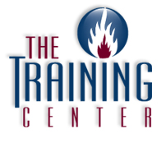
P.O. Box 966
John Moscatiello
Wrightstown, NJ 08562
1-800-392-3927 / 609-758-2100
Fax: 609-758-1495

HOW TO RENEW YOUR LICENSE

**IMPORTANT: Your first license is only valid for ONE YEAR and must be renewed BEFORE that first year expires.

Two Options:
3 year renewal- $80.00
1 year renewal- $40.00

To send in your renewal:
- You can renew up to 60 days before your license expires.
- Mail a check or money order for $80.00 (3 yr.) payable to the “Commissioner of Labor”
along with the top copy of your ID card.
- Mail your renewal to the current address (listed on your ID card)

NJ Dept. of Labor & Workforce Development
Bureau of Boiler and Pressure Vessel Compliance
PO Box 392
Trenton, NJ 08625-0392

IF YOUR LICENSE HAS EXPIRED:
Over 3 years expired: completely expired and you CANNOT renew it at all

Within 3 years of expiration date: It can be renewed upon paying a fine. You must call the state office at (609) 292-2345 to find out your fine.

IF YOU HAVE AN ADDRESS CHANGE:

Add a note with the change of address when you send in your renewal

**INFO IS ALSO AVAILABLE ON OUR WEBSITE**
www.boilertraining.com

